|  |
| --- |
|  |
| Md Najmul Islam  Agargaon, Dhaka **•** 1207 **•** +8801790349310 **•**  thatsnajmul@gmail.com |
|  |
| ▼ Objective It shows that you have thought about your career path and are actively seeking opportunities aligned with your professional goals. |
| ▼ Experience 01 apr 2022–30 may2023  Chandpur Motor and Bike Care**•** Shop Manager |
| ▼ Education  |  |  |  |  |  |  | | --- | --- | --- | --- | --- | --- | | Name of Degree | Institute Name | Board | Group | GPA | Passing Year | | SSC | Kumira Residential High School | Chittagong | Science | 3.56 | 2014 | | HSC | Tofazzol Hossen Manik Mia College | Barisal | Science | 4.42 | 2016 | | BSS | Siddeswary University College | National Universirty | Political Science | 3.10 | 2020 | |
| ▼ Personal Information Name : Md Najmul Islam  Father’s Name : Md. Kamal Hossen  Mother’s Name : Shahinoor Begum  Permanent Address : Village: South Chenchri, Post Office: Kaikhali Bazar,  Police Station: Kathalia, District: Jhalakathi.  Date Of Birth : 16 JUN 1999  Nationality : Bangladeshi (By Birth)  Religion : Islam  Gender : Male  Marital Status : Unmarried  Blood Group : O +(ve) |

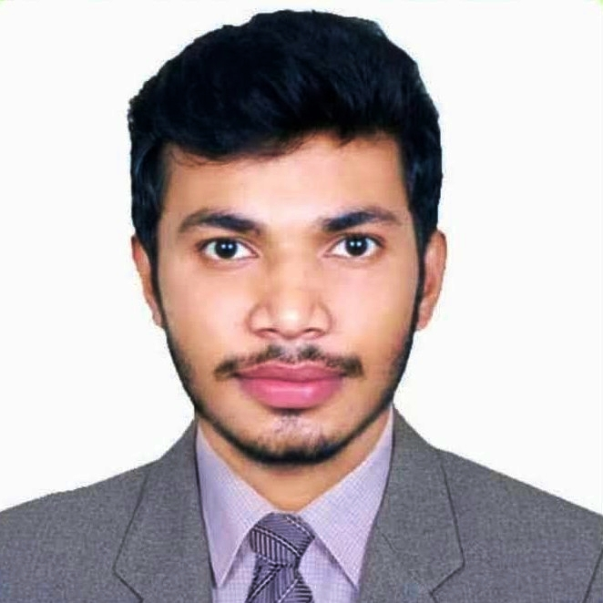

Md.Najmul Islam

Date: